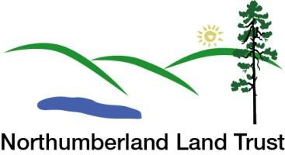
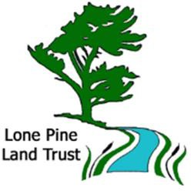
Speaker Series 2020
The Northumberland Land Trust & Lone Pine Land Trust ...

... welcome Gary Pritchard on Thursday, January 9, at 7:00 p.m. to the Venture 13 Auditorium, 739 D'Arcy Street, in Cobourg.
Gary will be presenting:

Aboriginal Perspectives on Conservation
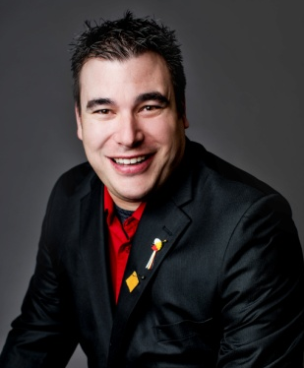
Gary Pritchard is Cambium Aboriginal’s Environmental and Climate Change Sector Manager with over 16 years of experience. In the past, Gary, a member of Curve Lake First Nation, has had the privilege to work on behalf of First Nations peoples throughout Ontario. He has travelled and worked in almost 300 First Nations communities throughout Canada and northern United States. He has brought a wealth of knowledge to both his Indigenous and non-Indigenous clientele, performing a wide variety of services including: Indigenous Community Planning, land-use/traditional knowledge studies, capacity building, mediator between western science and traditional science and peer reviewer on behalf of Indigenous communities. One of Gary's greatest strengths is that he is often able to be the one who acts as the bridge between the Indigenous Community and the western style of government. Gary has successfully collaborated with many stakeholder groups, researchers, institutes, government agencies, Indigenous communities, and political organizations to address environmental concerns and identify practical solutions to environmental related issues. Gary also serves as a technical advisor and professor at three post-secondary institutes within Ontario.

Cambium Aboriginal (https://cambiumaboriginal.com/) provides a wide range of consultation services.
Everyone is welcome to this free presentation which is delivered as part of a speaker series initiative by the Northumberland Land Trust and the Lone Pine Land Trust.

